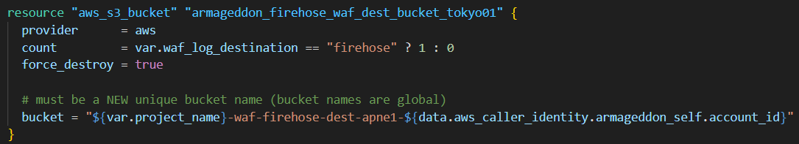
- provider = aws: uses your default AWS provider (you likely set this to Tokyo).
- count = ... ? 1 : 0: this is a switch.
  - If var.waf_log_destination == "firehose" → create 1 bucket.
  - Otherwise → create 0 (skip the whole setup).
- force_destroy = true: Terraform will delete the bucket even if it has objects inside (dangerous for real production, but handy for labs).
- bucket name: includes project_name, region hint apne1, and your account id to guarantee uniqueness (S3 bucket names are global).
Result: an S3 bucket like:
armageddon-waf-firehose-dest-apne1-123456789012

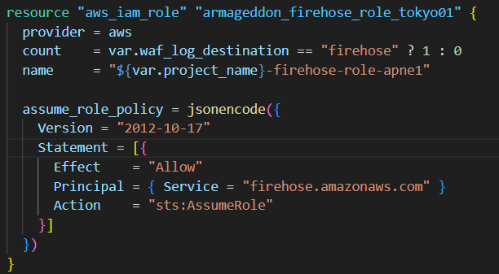
- Creates an IAM Role.
- The trust policy (assume_role_policy) says:
  - The AWS service Kinesis Data Firehose (firehose.amazonaws.com) is allowed to assume this role via sts:AssumeRole.
Result: Firehose has an identity it can use to call AWS APIs (like writing to S3).

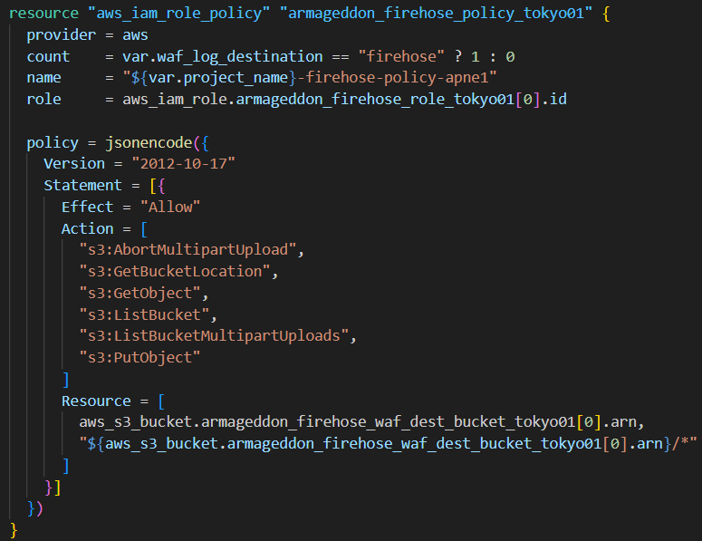
- This is an inline policy attached to the role.
- role = ...[0].id:
  - Because you used count, the role becomes a list.
  - [0] means “the first (and only) instance”.
- Allowed S3 actions are the minimum-ish set Firehose needs to deliver objects:
  - PutObject to write logs
  - ListBucket, GetBucketLocation to find/validate the bucket
  - Multipart upload permissions for larger batches (AbortMultipartUpload, etc.)
- Resource includes:
  - the bucket ARN itself (for bucket-level actions like ListBucket)
  - the bucket objects ARN (bucket/*) for object writes/reads
Result: Firehose can write log files into that bucket.

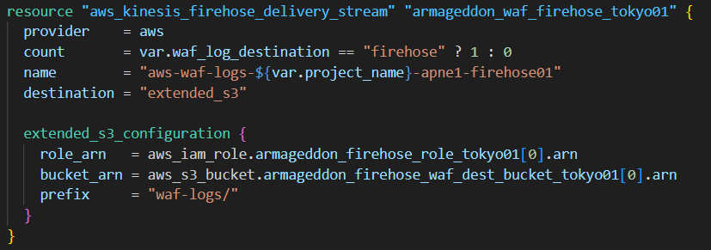
- Creates a Firehose delivery stream named like:
aws-waf-logs-armageddon-apne1-firehose01
- Sets destination to extended_s3 (S3 delivery with extra options).
- In extended_s3_configuration:
  - role_arn: Firehose uses the IAM role you created.
  - bucket_arn: where the data lands.
  - prefix = "waf-logs/": all delivered objects go under that folder path in the bucket.
Result: Firehose is ready to accept records and deliver them to:
s3://<bucket>/waf-logs/...

